User Manual:
Author – Oliver San-Blas:
Contents
Stage 1: 1
Dependencies required: 1
User Instructions: 1
Stage 2: 4
Dependencies required: 4
User Instructions: 4
Stage 3: 10
Dependencies required: 10
User instructions: 10
How the API works: 11

Stage 1:

Dependencies required:

For stage 1, the only dependencies required are an Integrated Development Environment (IDE) with Python 3.8 or higher. If the user has this installed, then they will be able to run stage 1 of the project problem-free, without having to install any additional libraries. If the user has an IDE without Python installed, then they will have to install it in order to run the program. Furthermore, since the components.py file is in the same folder as the game_engine.py file, they do not need to worry about finding and storing components.py in the same folder, in order for it to function.

User Instructions:
To start the game, user must simply open the game_engine.py file within the stage 1 folder and run the program in their IDE. They should be greeted by a welcome message along with the initial board outputted terminal and a message stating that it is “Dark’s turn”:
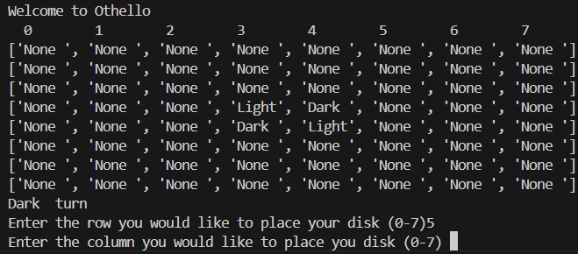
We can see that the user is also instructed to enter the row and column where they would like to enter their move. The input must be an integer between and including 0 and 7, with 0 representing the first row or column, and 7 representing the last row or column. The string of numbers above the string should hopefully make finding columns and specific cells easier for the user and reminding them that it is in the format of 0-7. If this row and column input is outside the domain and therefore invalid, an error message will appear:
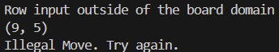
This error message notifies the user that the row input is outside the required domain and returns what the user inputted. In the example above, we can see that the user inputted 9 for the row and 5 for the column, leading to an error. Lastly, a final message will let the user know that this move is illegal and prompt the user to try again. The input will appear again and again for the user every time, until it is happy with the values entered:
Once the game has accepted two valid values for row and column, it will output the chosen coordinates, it will output the updated state of the board with the tiles flipped, the current move counter and will prompt the next player to take their turn:
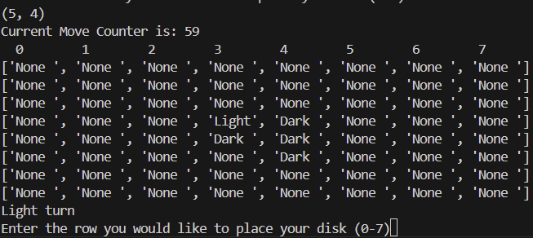
In this case above, we can see that the move (5, 4) entered by Dark has flipped the Light tile that was in the position (4, 4). Now, it is Light’s turn to move and they must follow the exact same process as Dark: enter a valid row and column between and including 0 and 7 to flip their opponent’s disks.
In very rare cases, one player will not have any legal moves available to them, so they must forfeit their turn to the other player, as long as the other player has legal moves still available. In this case, a message will be output letting both players know and that it is the other player’s turn again:
This move process repeats between Light and Dark until a victory has been reached, meaning that neither player has no more legal moves, or the move counter has hit 0, resulting in the game ending and the final board being printed. When this occurs, a “Game Over” message is printed, the tiles of each player are added up and the final scores are output, as well as a message determining who the winner is:
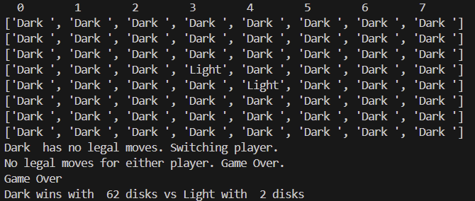
Above, we can see that neither player had any more moves available to them, so the game ends with a final score of 62 to 2 with Dark winning.

Stage 2:

Dependencies required:

For stage 2, the user must have the previously mentioned Python 3.8 or higher as well as Flask installed so that the frontend of the game is visible. If the user does not have Flask installed, they must go to their terminal within their IDE and use pip install to install Flask to their computer:
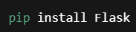
Once the user has Flask installed, they will be able to use the program perfectly and will be able to see the frontend created. Once again, the user will not have the worry about the subroutines imported from the different files such as components.py, game_engine.py or index.html are they are all within the same folder.

User Instructions:

Just like the previous stage, the user’s must run the flask_game_engine.py in their IDE to start the program. However, unlike the previous stage, they must click on the link created in the terminal by pressing CTRL + click to send them to the URL that contains the frontend of the game:
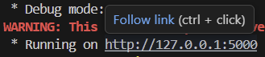
Once the user’s have clicked on the URL, there will be a tab on their browser that looks like this:
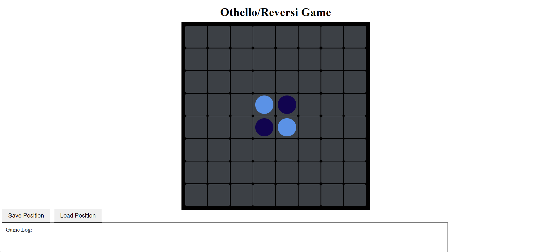
The Othello board is at the centre of the webpage and is where the users will make their move by clicking on the desired square and where the moves will be displayed. At the bottom of the screen is a Game Log, which will display error messages, the move counter, whose turn it is and the final score. Above the game log, there are two buttons: Save Position and Load Position. The Save Position button allows users to save the current position of the board mid-game, whenever they desire, and will be stored for later. The load position button then loads the saved board and updates the board to show the position that was saved previously:

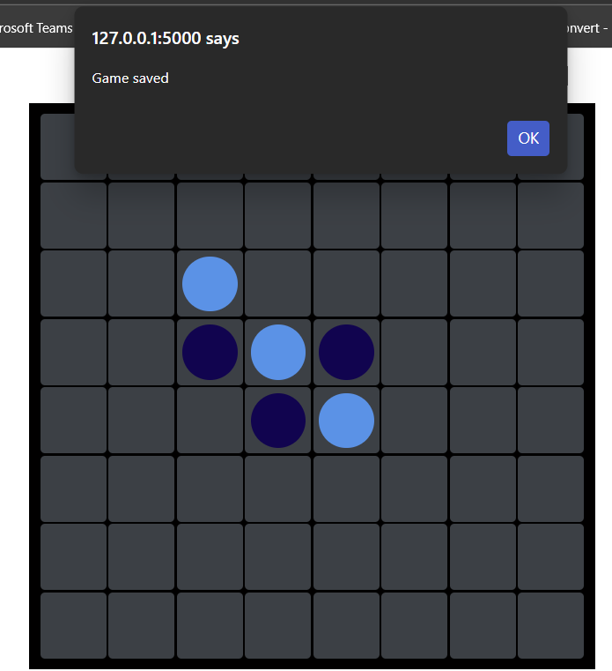
Here we save the game, to load again in the future, whenever we would like. The pop up message at the top notifies us that we have saved the game.
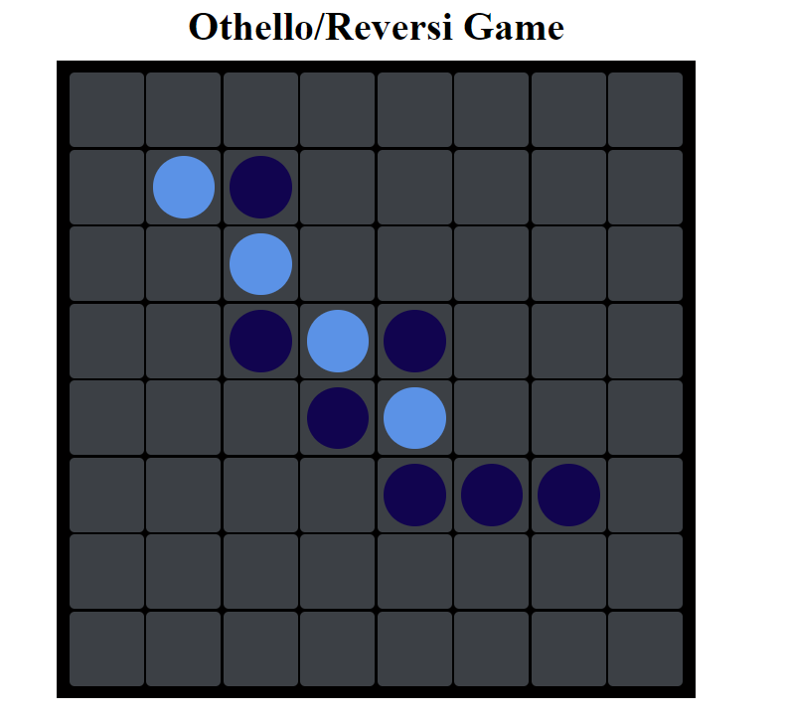
In this position, I would like to go back to the previous state of the board, when I had saved it, so I will press the load button.

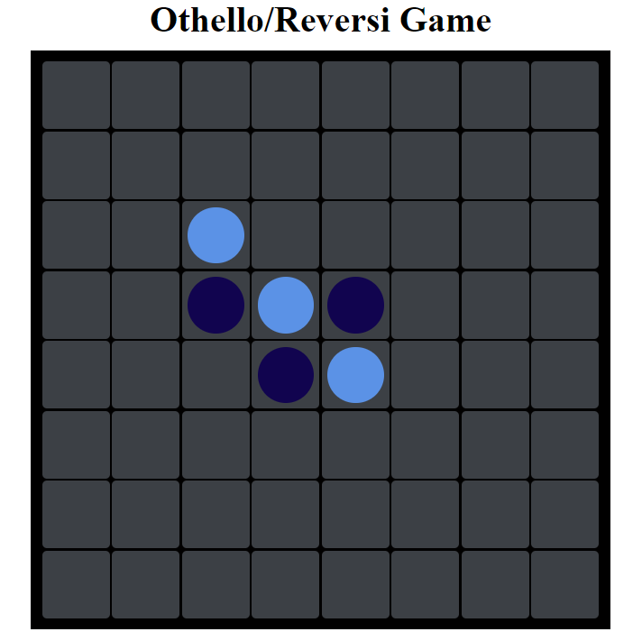
The game reverts back to the state it was at when it was saved, and we can carry on playing as if nothing had happened.
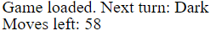
A message will appear in the Game Log notifying the user that the game has been successfully loaded. It is important to note that if it is Dark’s turn and the move counter is at 29, for example, and the game is saved, when it is loaded again, the move counter will revert back to 29 and it will be Dark’s turn as that was the state of the game when it was saved. Users must be aware that only one board can be saved at once, so if I originally save the board at move 2, and then save it again at move 6, when I press the load button, it will only display the most recent save as the save at move 6 overwrote the previous save. Furthermore, users are unable to load a game if the save button has not been pressed yet and this will result in an error message being outputted in the Game Log. However, that being said, if a user saves a game and then closes the program, they will be able to load the save, as it has not been lost.

To make a move, users must simply click on the cell of their choice given that the move is valid and legal. For example:
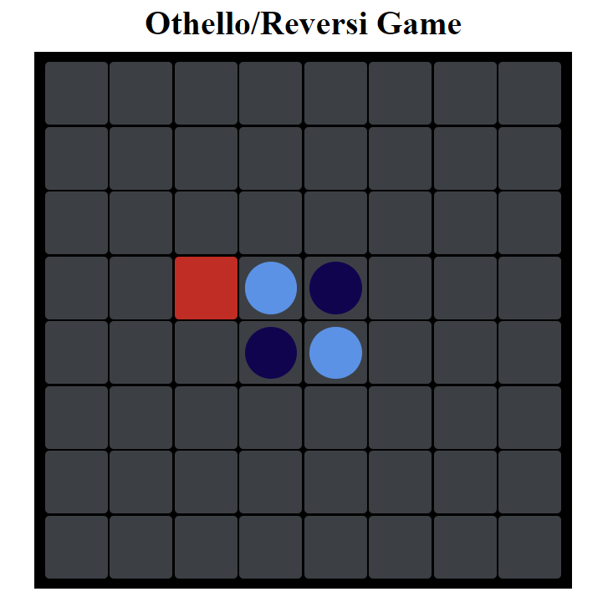
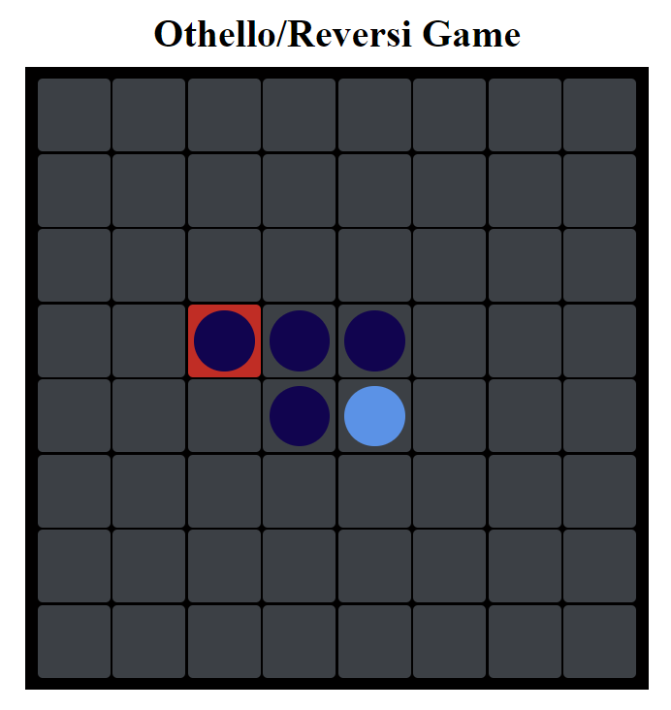
The board will then update according to the user’s move. The Game Log will also acknowledge the move and display the next player and move count:
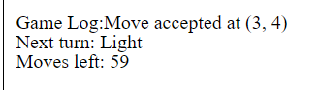
If the square selected is invalid, the Game Log will notify the player and output:

If the square selected has already been taken, the Game Log will notify the player and output:

The game will then continue until the board is full or both players have no moves as mentioned before. When the game ends, the Game Log will output the game over message, notifying the players who has won, and the final scores:
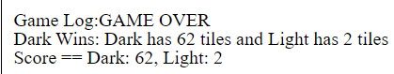
At this point, users are unable to make any more moves, so they must restart the program if they would like to play again or they can load the game from a saved position, once the game is over, if they would like to play again from that specific position.
To quit, users must press CTRL + C to end the Flask server and allowing them to start again or quit playing if they would like:

Stage 3:

Dependencies required:

For stage 3, the dependencies required for the program to run are the exact same as the dependencies required for stage 2. The user must have Python and Flask installed in order for the game to work.

User instructions:

To play the against the AI, the user does the exact same thing as stage 2 and clicks their desired square where they would like to place their disk. The only difference is that now, the AI will move automatically as soon as the player moves themselves, so the player only needs to worry about their moves this time. As a result, the Game Log will only output the moves of the player as the moves of the AI will always be valid and legal, so player can also only focus on their moves in the Game Log:
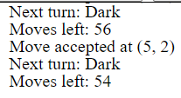
The save and load buttons still work exactly the same except that this time only Dark tiles (the player) can save and load the game as it is something that the AI is unable to do.
Lastly, the game will end the same too, with the game ending once neither player has any moves or the move counter has reached 0, with the score being outputted in the Game Log:
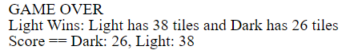

How the API works:

For users to implement their own GUI that they have designed, they must keep certain things into account about the API:

The backend stores the board, the current_player and the move_counter as well as all of the Othello logic so users do not have to spend time rewriting this logic and can instead just change the GUI. There are 3 endpoints that users must be aware of before implementing their own API:

This endpoint simply returns the html GUI created, however, this is not required for custom GUIs.

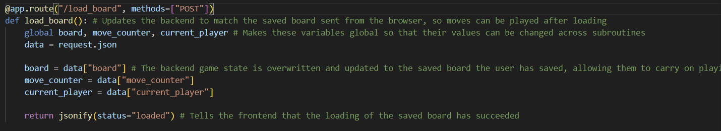
The POST /load_board endpoint is responsible for loading the same game once the load button has been pressed, by replacing the backend state with the previously saved game
{
"board": [...],
"move_counter": 42,
"current_player": "Dark "
}
This data is the data requested by the frontend which must be then displayed by the GUI once it is replaced in the backend.
{
"status": "loaded"
}
Once the GUI loads the game it responds with “loaded”.
3) 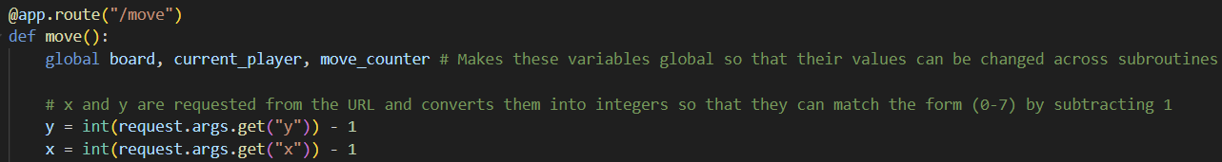
Lastly, the GET /move endpoint is use to make a move a (y, x) by requesting x and y as URL query parameters which are then returned by the GUI, to allow users to make a move.

This endpoint has three reposnse types:
{
"status": "success",
"board": [...],
"player": "Light",
"movesLeft": 59
}
- A successful move – Meaning that the move was valid, the player has been switched and the board has updated, meaning that the GUI must update too to show the new board.
{
"status": "fail",
"message": "Cell is not empty",
"board": [...],
"movesLeft": 60
}
{
"status": "fail",
"message": "Not a legal move",
"movesLeft": 60
}
- An illegal move – Meaning that the move has been rejected due to it being invalid, so the GUI must display an error message letting the user know that this is the case
{
"finished": true,
"message": "Light Wins: Light has 34 tiles and Dark has 30 tiles",
"board": [...],
"scoreDark": 30,
"scoreLight": 34
}
- Game finished – When get game is over the API returns the score, the message and the final board. The GUI must display this information to the user and stop allowing moves.
Therfore, an GUI must be able to manage all of these endpoints successfully without errors to ensure a smooth running of the game.
A custom GUI must be able to implement:
- Render the 8x8 board visually using the board array from the API
- Detect clicks and send API requests using “/move?y=X&x=Y” to determine the user’s move
- Display message to inform the user if their move is invalid, if the game has been saved and when the game has ended
- Provide save and load buttons giving users the functionality to reload previously saved games
- Update visuals after each API response to provide an accurate representation of the board
Therefore, a GUI must be able to handle all of these cases successfully for the program to work seamlessly with a different GUI without changing any of the core components of the API. Users should keep this list as well as the endpoints in mind whilst designing their GUI to ensure perfect combatibility between the frontend and backend.

MIT License

Copyright (c) 2025 Oliver San-Blas

Permission is hereby granted, free of charge, to any person obtaining a copy of this software and associated documentation files (the "Software"), to deal in the Software without restriction, including without limitation the rights to use, copy, modify, merge, publish, distribute, sublicense, and/or sell copies of the Software, and to permit persons to whom the Software is furnished to do so, subject to the following conditions:
The above copyright notice and this permission notice shall be included in all copies or substantial portions of the Software.
THE SOFTWARE IS PROVIDED "AS IS", WITHOUT WARRANTY OF ANY KIND, EXPRESS OR IMPLIED, INCLUDING BUT NOT LIMITED TO THE WARRANTIES OF MERCHANTABILITY, FITNESS FOR A PARTICULAR PURPOSE AND NONINFRINGEMENT. IN NO EVENT SHALL THE AUTHORS OR COPYRIGHT HOLDERS BE LIABLE FOR ANY CLAIM, DAMAGES OR OTHER LIABILITY, WHETHER IN AN ACTION OF CONTRACT, TORT OR OTHERWISE, ARISING FROM, OUT OF OR IN CONNECTION WITH THE SOFTWARE OR THE USE OR OTHER DEALINGS IN THE SOFTWARE.

